Understanding the Impact of Economic, Demographic, Energy Factors & Plastics on Global Warming
Springboard Capstone II Project Report
Sailee Gawande
- Introduction

Global Warming has been on the rise over the past several decades due to Industrialization and human activities like burning fossil fuels for plastics production and fulfilling growing energy demand. As a result, global CO2 emissions have also risen significantly. This could eventually lead to endangered ecosystems and decreased biodiversity on earth.

Supply Chain decision makers are always faced with challenges to reduce emission levels and meet environmental targets for sustainability and appropriate long-term investments while supporting economic growth and operational efficiency. In many cases, they lack clarity in terms of quantitative analysis regarding how national economic activity, energy consumption, demographic trends, and the expanding role of plastics collectively influence greenhouse gas emissions over time.

This project seeks to address this challenge by modeling carbon dioxide (CO₂) emissions as a key indicator of climate impact. By using historical country-level data on economic output, energy usage, and population alongside global plastic production, this analysis aims to uncover the key drivers of emissions. By developing predictive models and analyzing long-term trends, the goal is to generate actionable insights that support supply chain stakeholders in making informed decisions and advancing more sustainable supply chain strategies.

- Problem Statement

How can we predict and provide actionable insights regarding the impact of national economic activity, energy usage and demographic indicators within the context of increasingly plastic intensive global supply chains over the past many decades on global warming using carbon dioxide emission levels as our key indicator?

- Data Wrangling
Two datasets consisting of global plastics production data and CO2 country year data were selected for this analysis from https://ourworldindata.org/.
After data wrangling, we ended up with 2 transformed datasets
- CO2 Country Year Dataset from 1990-2019
- Global Plastics + CO2 Dataset from 1990-2019
Following were the main steps for cleaning, filtering and transforming both datasets.
CO2 Country Year Dataset from 1990-2019
- Reduced dataset from 79 to 10 relevant features that captured core features such as GDP, population, and energy/capita and were not decompositions or transformations of target variable CO2 as it would compromise model validity.
- The dataset contained records for regions other than countries. So, filtering was done for country-level records only.
- The dataset was filtered for timeframe of 1990–2019 as least amount of CO2 emissions data was missing for that time period, and Plastics data was not available past 2019.
- Approximately 25% of data was missing for GDP so low-impact missing GDP records were removed.
Global Plastics + CO2 Dataset from 1990-2019
- First the global plastics dataset was checked for missing, duplicate and outliers’ data. Next, some columns were transformed into more readable names and metrics. Ex. million tonnes instead of tonnes.
- Next, the global plastics and CO2 country-level datasets were merged by first converting the CO2 dataset to global year level and transforming some column metrics.
- We also plotted the key features and our target variable from this global dataset for trends and outliers’ identification. We found that despite all other features increasing in value over the years including our target indicator of CO2 emissions as expected, energy per GDP and CO2 per GDP decreased as shown below.

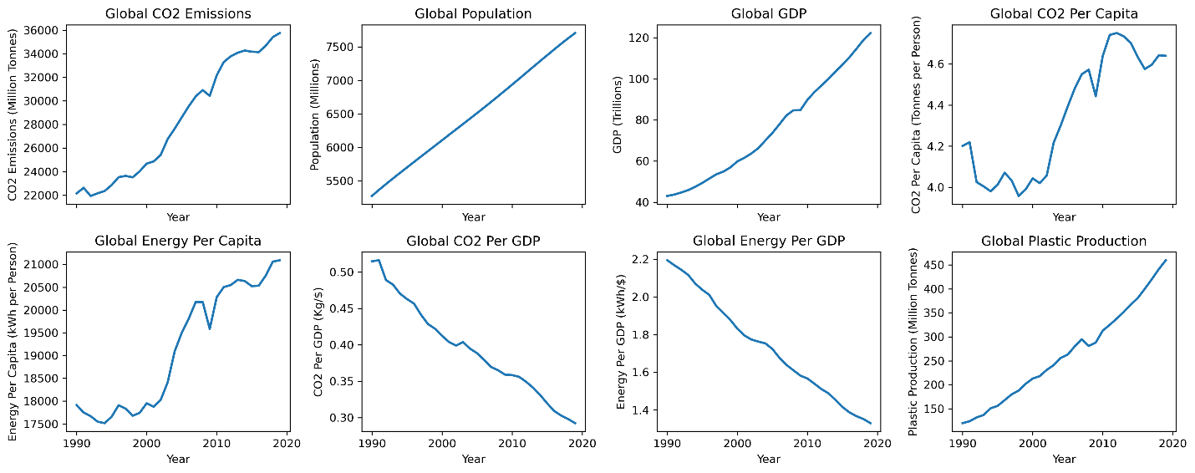
- Exploratory Data Analysis

Exploratory Data Analysis was done for both Global & Country level datasets.

Global CO2 Plastics Dataset (1990-2019)

- Trends Charting was done on the normalized features dataset meaning we normalized all features with index = 100 in the starting year. Again, same trend was observed as in the trends chart above in Data Wrangling phase. All core features, GDP, energy use per capita, plastics production and population, showed consistent growth for our study period of 1990-2019.
- CO2 emissions per unit GDP and Energy per Capita use per unit GDP saw an opposite downward trend indicating energy efficiency improvements. However, these gains have not been sufficient to offset the economic, demographic, energy demand and CO2 emissions trend that continues to rise globally.
- Energy use per capita change seems to have the strongest relationship with CO2 emissions change year over year (correlation of 0.81).

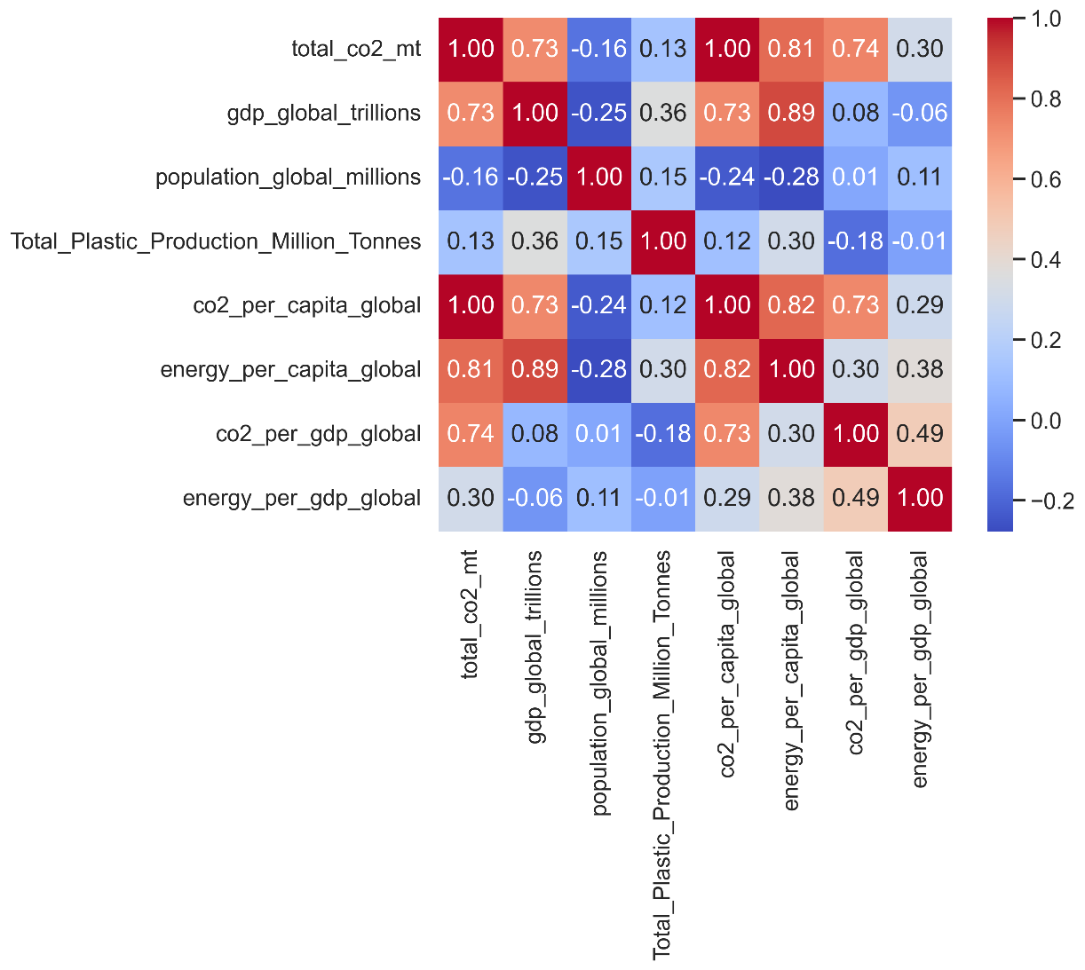
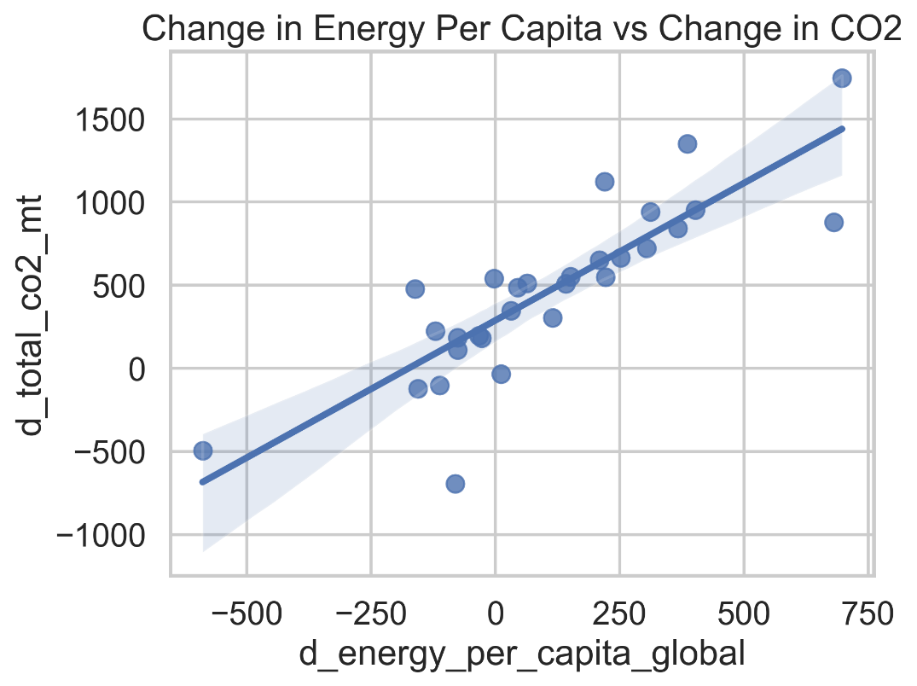
- Strong multicollinearity was observed among all the core features in this global dataset of limited size (only 30 rows) making it difficult to use this for modeling and drawing causal inference based on this data.

CO2 Country Year Level Dataset (1990-2019)

- Energy Consumption Per Capita seems to have a strong positive correlation with CO2 emissions in the country level dataset as well, suggesting its key role in global warming. We also see that higher GDP per capita & population size countries are concentrated on the top right indicating that higher economic development and population size also result in higher energy demand and hence higher CO2 emissions.
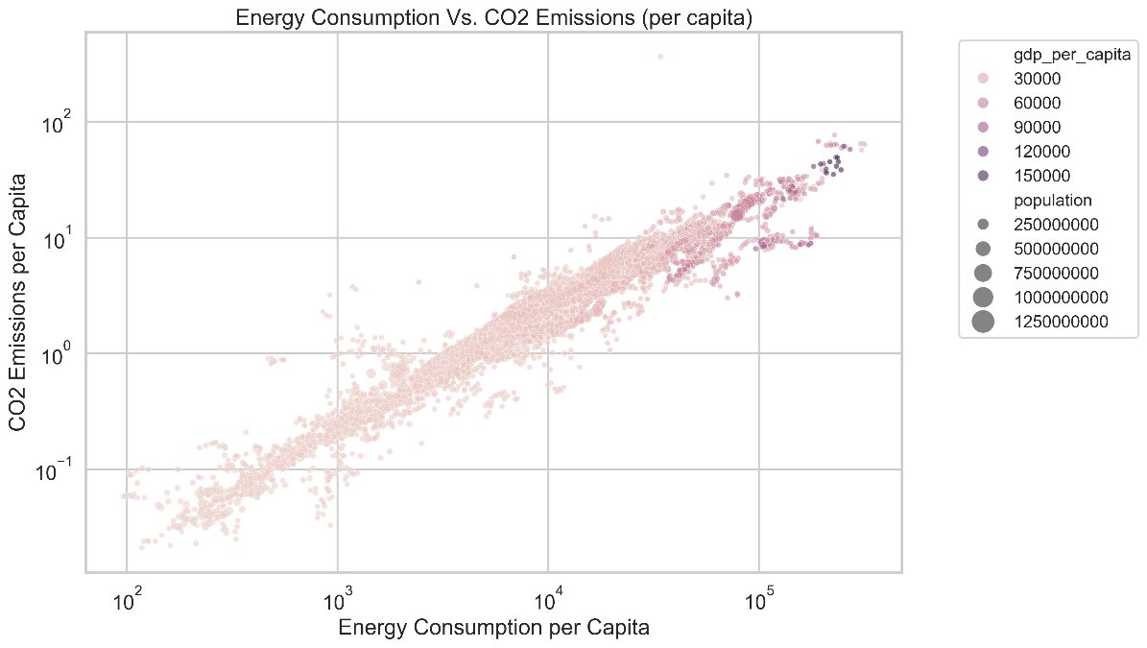
- GDP Vs. CO2 emissions plot suggests that developed economies like United Kingdom show decoupling between economic growth (GDP) and CO2 emissions suggesting CO2 emissions stabilize or decline over time due to potential energy efficiency and green projects.
Developing Economies like India, China, South Korea with strong economic growth show a tight relationship with CO2 emissions.

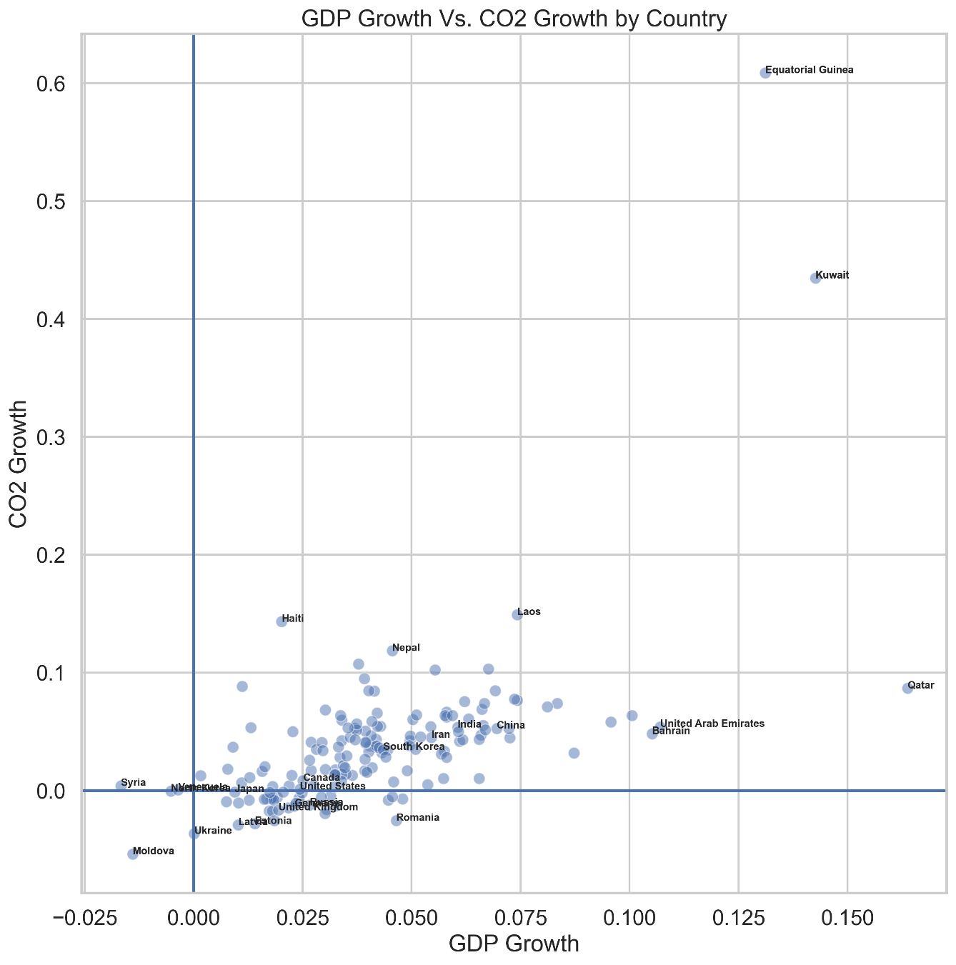

- All feature distributions for GDP, population, energy and CO2 were found to be right skewed with skewness varying in severity. Hence, we decided to use log transformation of these features for modeling as the distributions looked more symmetrical while still being correlated and multicollinearity is not severe. They also provide more acceptable statistical properties for regression modeling.
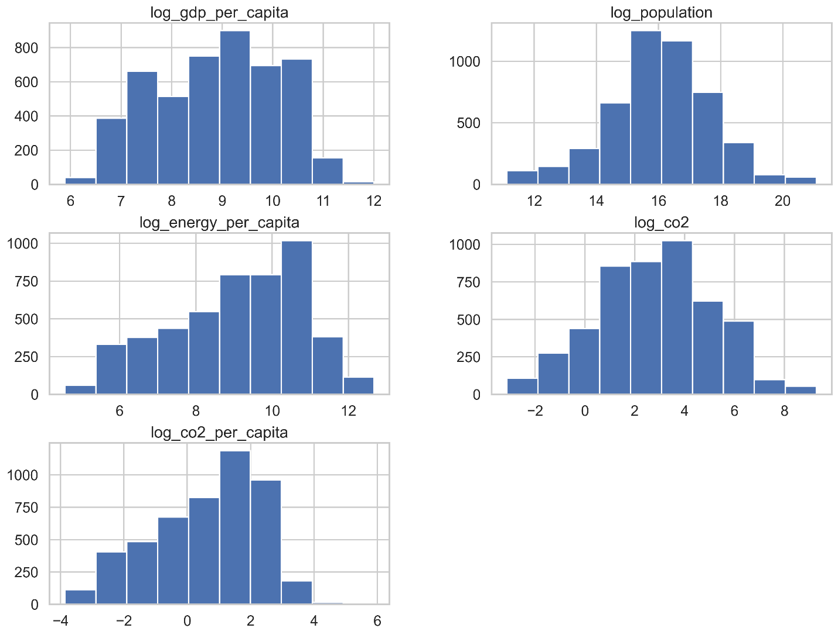

- Dataset for Preprocessing and Train/Test sets creation with log features was saved for next step.

- Preprocessing & Train/Test Sets

In this phase, the CO2 master dataset was checked for completeness, and following tasks were done to ensure model ready dataset.
- Principal Components Analysis was done to improve multicollinearity on our standardized log features for energy, GDP and population. The first 1 to 2 features captured majority of the variance. However, since the components were a combination of features, it reduced interpretability. We decided to stick with the original features as they were more interpretable, did not have severe multicollinearity and we did not need dimensionality reduction for our dataset because we only had 3 features to begin with.
- We decided to take 2 modeling approaches as they captured different perspectives for emissions.
- First one to model for Total CO2 Emissions using GDP Per Capita, Energy Per Capita and Population as our features.
- Second one to model for CO2 per capita using GDP Per Capita & Energy Per Capita as our features.

- Train/Test splits for both approaches were done in a time-aware manner since our dataset is a time series (country/year level data for 19 years).
- All numerical features were standardized to ensure model readiness.
- Finally, all train and test sets were saved for modeling in our next step.

- Modeling

- Two modeling approaches mentioned in the section above were implemented for modeling Total CO2 Emissions and CO2 per Capita with the following models

- Ordinary Least Squares Model (Scaled and Unscaled).
- Scaled Ridge Regression Model with Hyperparameter Tuning, Cross Validation & Feature Importance Assessment.
- Random Forest Model with Hyperparameter Tuning, Cross Validation & Permutation Importance for Feature Importance Assessment.
- RMSE, MAE and R2 metrics were used for model evaluation.
- Model Approach Findings
- For the first model with log_co2 (Total CO2 Emissions) as our target & log_population, log_energy_per_capita & log_gdp_per_capita with countries as categorical variables, the models had a good predictive performance. However, population signal dominated all other features as developing countries with huge populations potentially tend to contribute significantly towards total CO2 emissions. So, we had a scale effect with this strategy, and it was not very useful for interpreting efficiency.
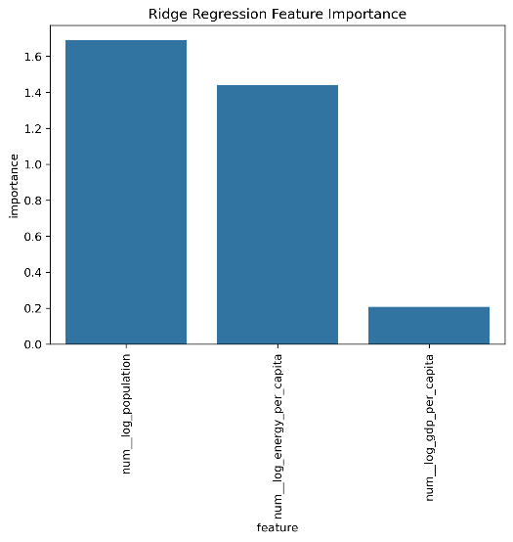
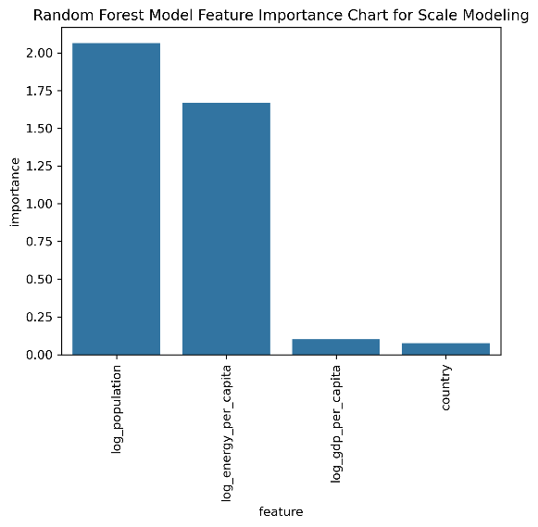

- For the second model, log_co2_per_capita was our target and log_energy_per_capita, log_gdp_per_capita were our primary features. This model had higher interpretability as it captured CO2 emissions intensity rather than scale and it aligns better with sustainability and decoupling analysis.
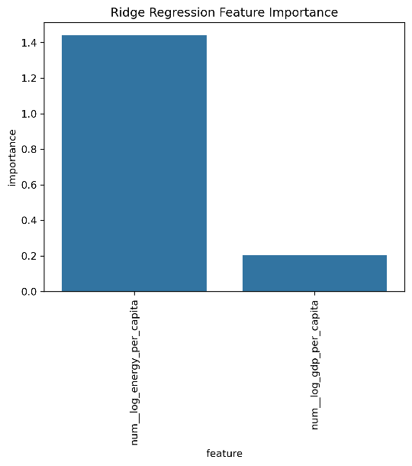
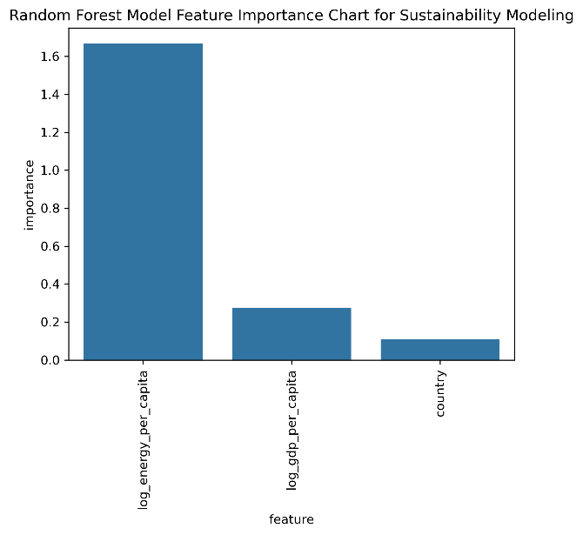

- We observed that total CO2 models achieved higher R2 due to population dominance whereas CO2 per capita models showed slightly lower R2 but greater interpretability.
- Both Ridge Regression and Random Forest model confirmed Energy per capita as the strongest predictor, GDP per capita as secondary with minimal reliance on country-specific effects for the CO2_per_capita model.
- Hence, we decided to model for CO2_per_capita using Ridge Regression model since it performed the best. Below are the performance metrics for all models and approaches.

- Plastics Connection

While we modeled country level carbon dioxide emissions using energy, economic and demographic indicators, we know based on our exploratory data analysis that global plastics production has increased a lot over the past several decades alongside global GDP, energy per capita and population.

We can see from the indexed global CO2 and plastics production chart below that plastics production has increased over 280% in the last 3 decades while global CO2 emissions have increased by ~60%. While both show a growing trend, slower CO2 emissions growth seems to be primarily due to cleaner technology and energy efficient/green projects and processes. However, the rapidly growing plastics production indicates rising environmental pressure from supply chains and continues to contribute towards CO2 emissions and hence global warming.

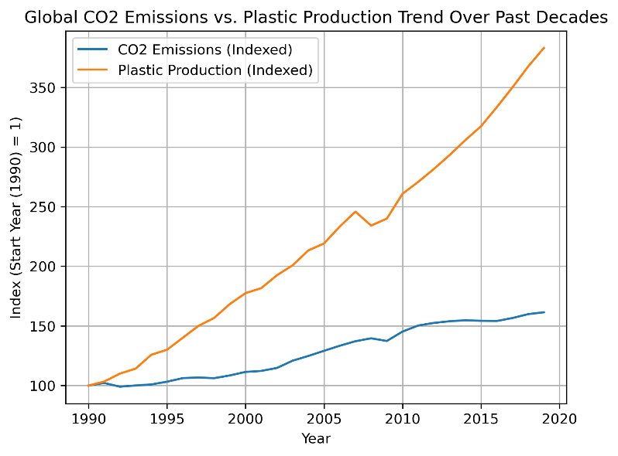
The strong positive correlation shown below between Global CO2 Emissions and Plastics Production further supports their co-movement over the past several decades.

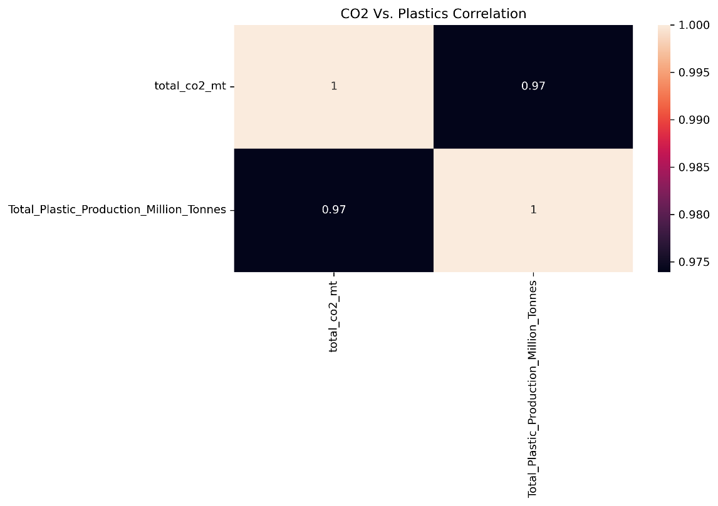
This further strengthens our narrative of Plastics Production being a macro driver of CO2 emissions and hence global warming.

- Key Takeaways and Recommendations
- Our main insight from this analysis is that energy consumption behavior is the most critical driver of CO2 emissions intensity. To reduce CO2 emissions and global warming, focus on energy efficiency and cleaner energy sources is more critical compared to economic growth and population factors especially for plastic intensive supply chains globally.
- Following are the actionable recommendations
- Track both CO2 per capita and CO2 Emissions for all major energy intensive industries & processes within a country.
- Invest in energy efficient technologies.
- Incentivize green/renewable energy sources.
- Invest in recycling and improving Supply Chain sustainability.
- Reduce dependence on plastic by investing in greener alternatives.

- Conclusion
While all features considered in this study like GDP, Energy, Population and Plastics contribute to CO2 emissions, energy consumption behavior has the highest environmental impact. Hence, the focus should be on energy efficiency within the context of global plastic supply chains to reduce global warming.
- Future Work

- Add country/year level plastics data for using plastics as a feature for modeling CO2
emissions.
- Add renewable energy indicators to clearly measure the impact of both non-renewable and renewable energy sources on global warming.
- We can further explore panel regression models that would capture country specific temporal dynamics in a better manner and provide more insight into country specific emission drivers.

